Dear Dr. Thornhill
After viewing the EU 2015 conference lectures, I was somewhat confused by what I understood from the 'long path to understanding gravity' lecture, where the electric dipole, seemed to me, to be created by pre-existing gravity, and perhaps to some extent it is. But, in the lecture, I could not find a way to initialize the process of creating 'first gravity'. I use the term 'gravity' here meerly as a name for an electric attraction between unlike elementary (electron / proton) charges.
I constructed a two dimensional model of three hydrogen atoms arranged as a triad with the orbital path of each electron just touching the orbital path of each neighboring atom's electron. To simplify the calculations, I considered only one interaction between two atoms, A and B, expecting that the same calculations would apply between each atom and its two neighbors, for a total of six force vectors, which would reduce to three dot product forces, all pointing toward the center of the triad if the net force was attractive, and pointing away from the center if the net force was repulsive.
The following sketch depicts what I have in mind. Atoms A and B, where the orbiting electron of B becomes nearer and further from the proton of A.

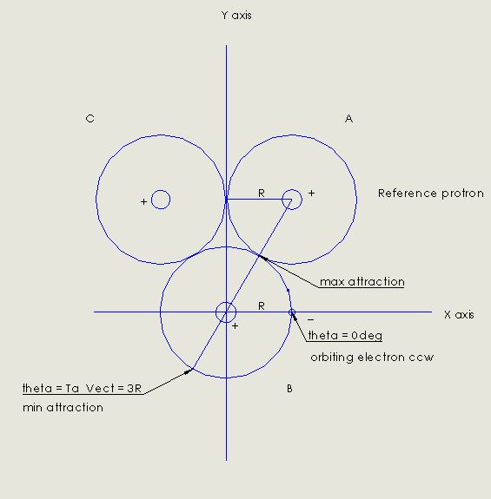
Page 2 - is an image of the MathCad calculation layout of constants and values with annotations, that are used to calculate the magnitude of the force vectors, and reduce them to average values.
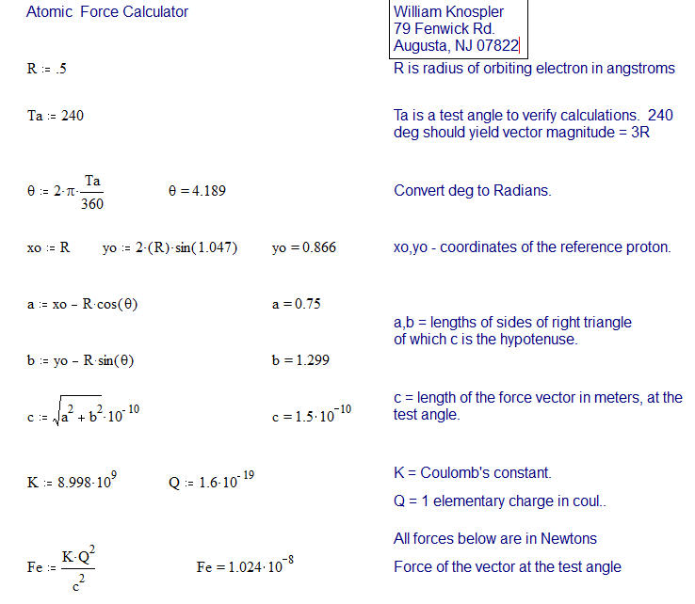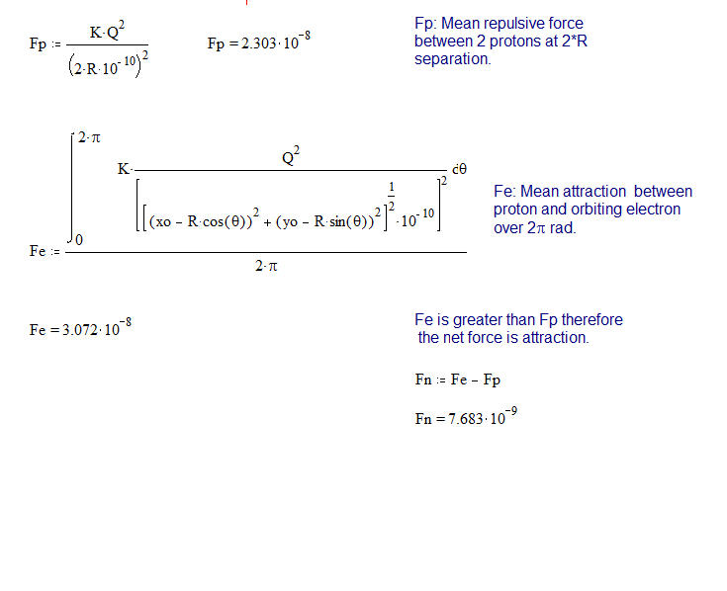
Page 3 - plots the magnitude of forces at 100 points per radian. MathCad plots by integers which would result in a graph of only 6 data points were it plotted in radians directly.

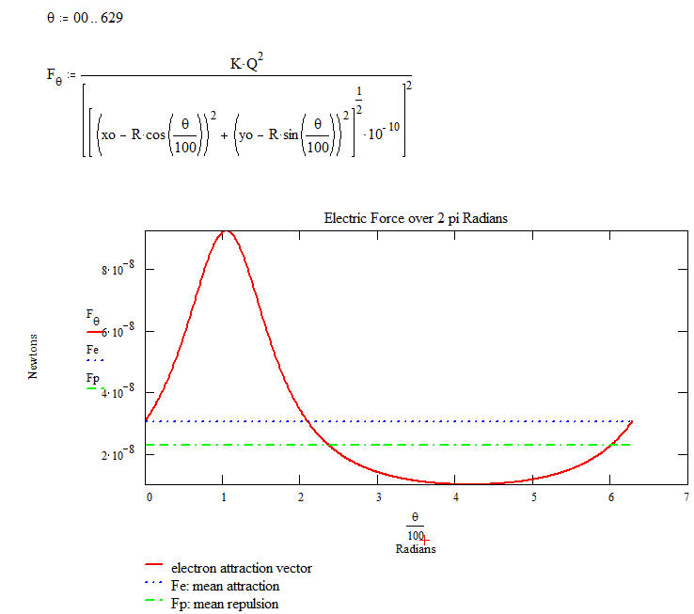

This exercise seems to show that an attracting force acting between each proton and a neighboring electron, would pull the proton toward the center of the construction for a portion of the electron's orbit, while during the remaining portion of the orbit the proton - proton repulsion exceeds the attracting force and repels or pushes the proton back toward the center of the atom. Since the net force, over one electron orbit is attractive and greater than the constant proton - proton repulsion force, one might expect that the proton would oscillate or dither in unison with the electron's position in time, but on average would spend more time per orbit drawn off-center of the atom, and toward the center of gravity.
This slight net displacement would then account for the creation of an electric dipole as explained in your lecture EU 2015. I would expect that the forces involved in this periodic attraction - repulsion dance, which are indicated in Newtons, are much greater than the force created by the resulting dithering dipole, which would be consistent with the very weak force we call gravity.
I have given some consideration to the fact that there also exists a degree of electron - electron repulsion between any two atoms. I would expect that since nature is inclined to take the path of least resistance, the electrons would find an orbital phase relationship with respect to each other that would minimize the repulsion between electrons for any atomic geometric configuration.
I hope I have adequately described this construction and further, that you find this idea interesting and useful, and perhaps even a basis for going forward in our understanding of what makes things work in this magnificent universe. If you find that I have made some error, or have any comments or suggestions whatsoever, I would appreciate knowing that as well.
Thank you for your time and consideration.
I am sincerely
William Knospler

PS. In my efforts to inform my friends and colleagues regarding the false science that has been forced upon us over the past 100 years, I have developed a simple thought experiment that can be easily understood by those who are not scientifically minded, pertaining to a proof that a black hole cannot exist at the center of a spiral galaxy, nor can a condition supporting hydrogen fusion exist at the center of the sun.
Having been involved myself, with gamma ray spectroscopy using NaI crystal detectors and multi-channel analyzers and having observed attenuated photo-peaks, from Cs137 sources, located in the Compton spectra and resulting from the Compton Effect, it has always troubled me that energy loss due to Compton scattering has not been considered as a partial cause for the observed Red Shift of light coming from distant galaxies.

